**Practice Project 1**

**Creating an Arithmetic Calculator**

**Sai Krishna Rajagopal**

**22-02-2022**

**GITHUB Repository URL:** [**https://github.com/SaiKrishna6699/CoreJavaTraining.git**](https://github.com/SaiKrishna6699/CoreJavaTraining.git)

**Technical Summary:**

1. **Java**
2. **Eclipse**
3. **Git**
4. **Java:**

The Arithmetic Calculator was developed in Java Programming Language using the concepts of Variables, data types, operators, type casting, control statements, class, objects, access specifiers, and core keywords like final.

* The Application is fully functional and working perfectly with No Exceptions

Short Summary of code:

* + Two classes were created for in the application.
  + The main class contains the Working of the application.
  + The second class contains the Methods Multiply and Division using the Protected Access modifier and Inherited to the Main class
  + In the main program there are two methods Addition and Subtraction with Protection Access Modifier
  + The Inputs were taken using Scanner class
  + The Variables X and Y are initialized using Float Data Type.
  + The Variable Operator using Char for operator
  + The Variable Result is also a Float
  + Switch case Control Statement is used to select the operation of calculating the variables
  + Do While Loop is used to run the Control Statement for Finite looping.
  + Finally, the Final Keyword is used to make the Result variable to finalize the value of Result variable and at the same time Type casted the Variable from Float to Double (Implicit Type Casting).
  + Finally, the result will be the output of the code.

1. **Eclipse:**

Eclipse is the IDE used to Write the code. It is a very programmer friendly and easy to use application.

1. **Git & GitHub:**
   1. Git is the version control system used to store the data in a remote Repository.
   2. GitHub is the remote data base contains repository which is used to store the data.

Git Commands used:

$git init

$git remote add origin “[**https://github.com/SaiKrishna6699/CoreJavaTraining.git**](https://github.com/SaiKrishna6699/CoreJavaTraining.git)”

$git remote -v

$git add .

$git commit -m “First Commit”

$git branch -M main

$git add ArithmeticCalculator

$git push -u origin main

1. Screenshots:

Code:

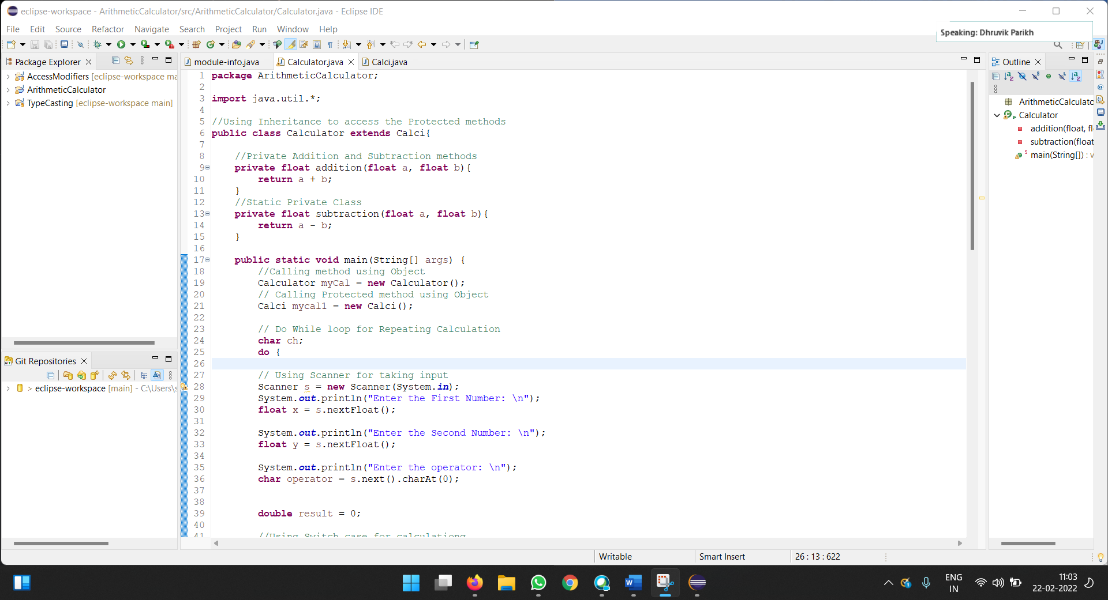

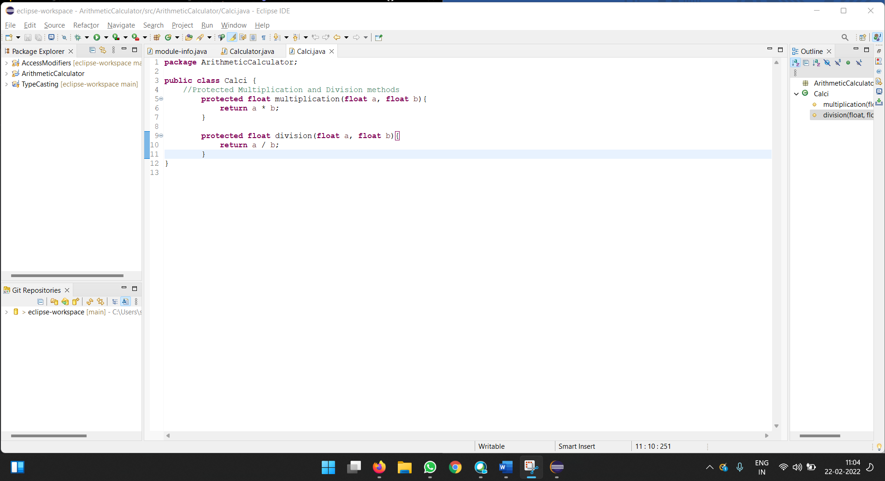

Output Sc shot:

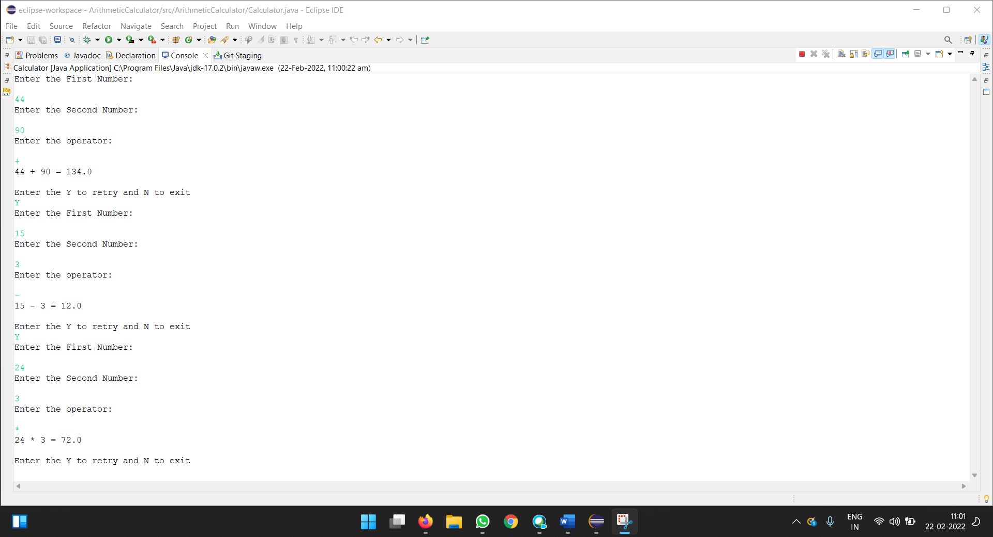

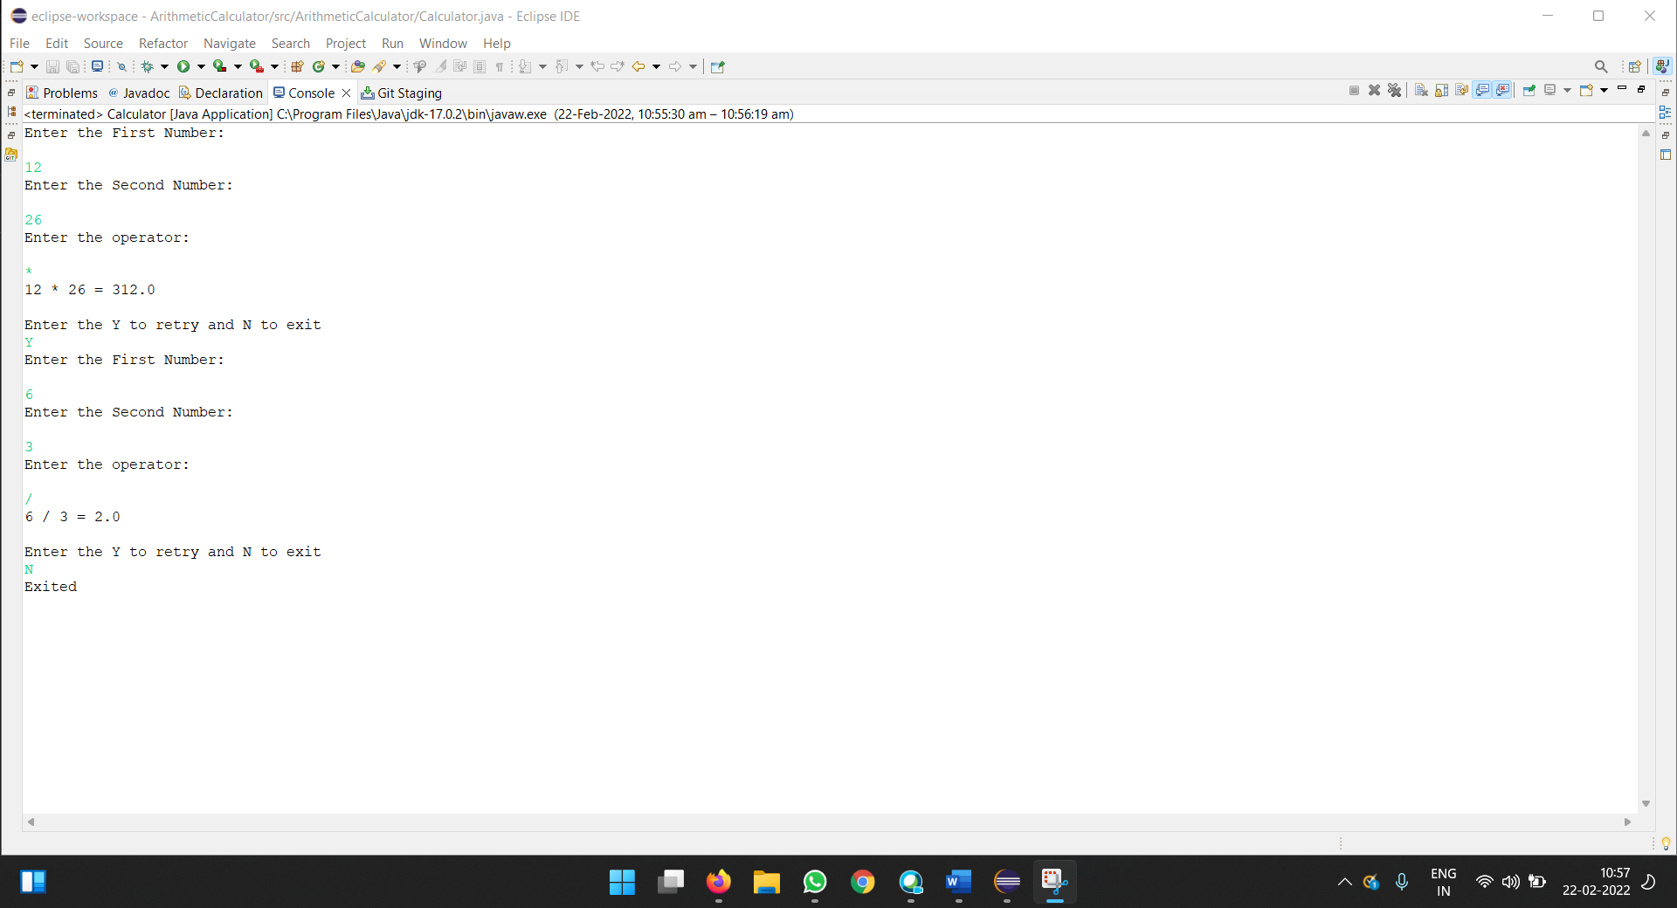

Git Commands:

